**Criterion B: Development**

This is a Java program simulates a banking interface. Its functions include being able to login to your account, deposit, withdraw, and transfer funds. It also has the ability to create new accounts and have the user be able to login with their new account.

**List of Techniques**

* Object Oriented Programming
* Reading from a file
* Writing to a file
* Parameter passing
* Error handling for invalid file
* Handling user input from a GUI

**Programing Structure**

The program opens up with a GUI where the user can either enter in their credentials and login or create an account. Once logged in, the user can navigate through tabs so they can deposit and withdraw funds. The program sends these input amounts through OOP to another class so the program will run through the file and write to it. The program will read from that transaction file to show how much funds the user has.

**UML Diagram**

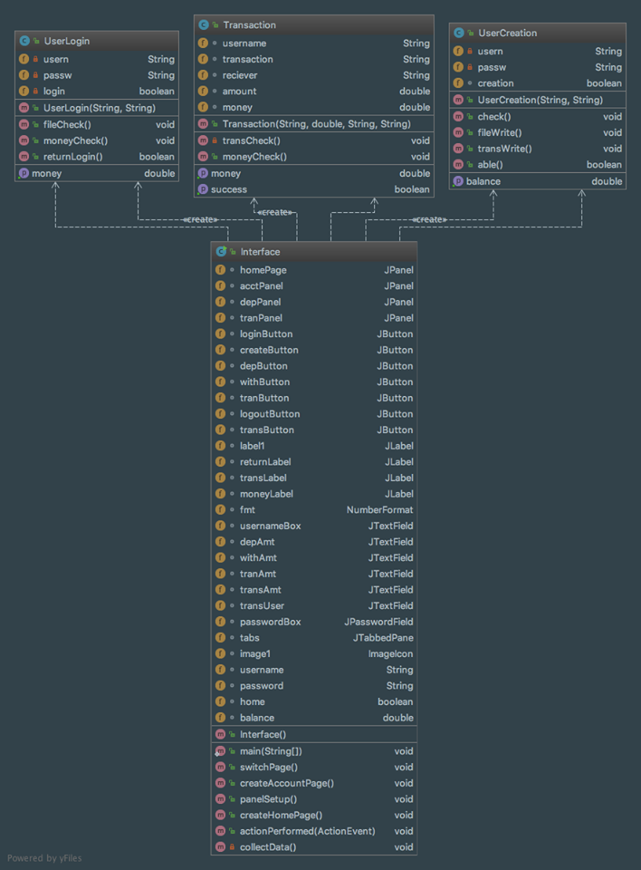

**Complex Code**

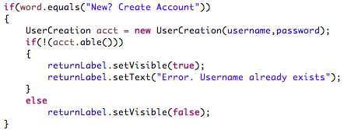

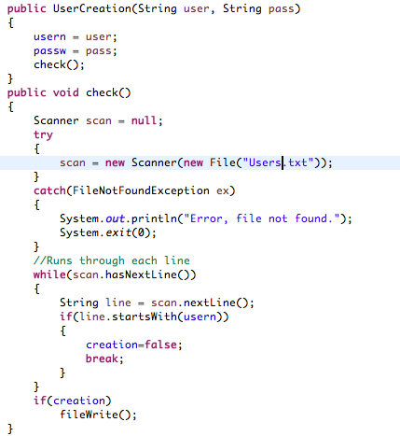

* Inputs the username and password from the text fields
* Uses loops and if statements to check if there is a username that exists
* If there is no account with that username, it creates the new account by writing to the file

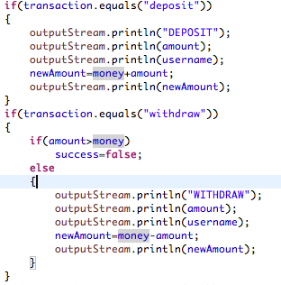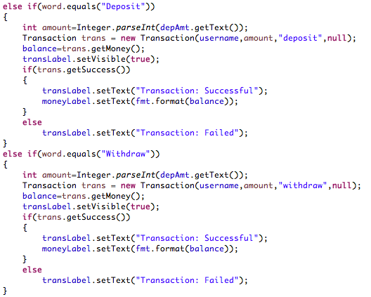

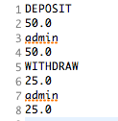

* Takes in the amount and what type of transaction it is
* Using OOP, sends this information as an object to the Transaction class to process it and write the information to a text file

**Word Count:** 235